Restaurant Management System

Phase II

Kun Chen, Rui Da, Yi Yang

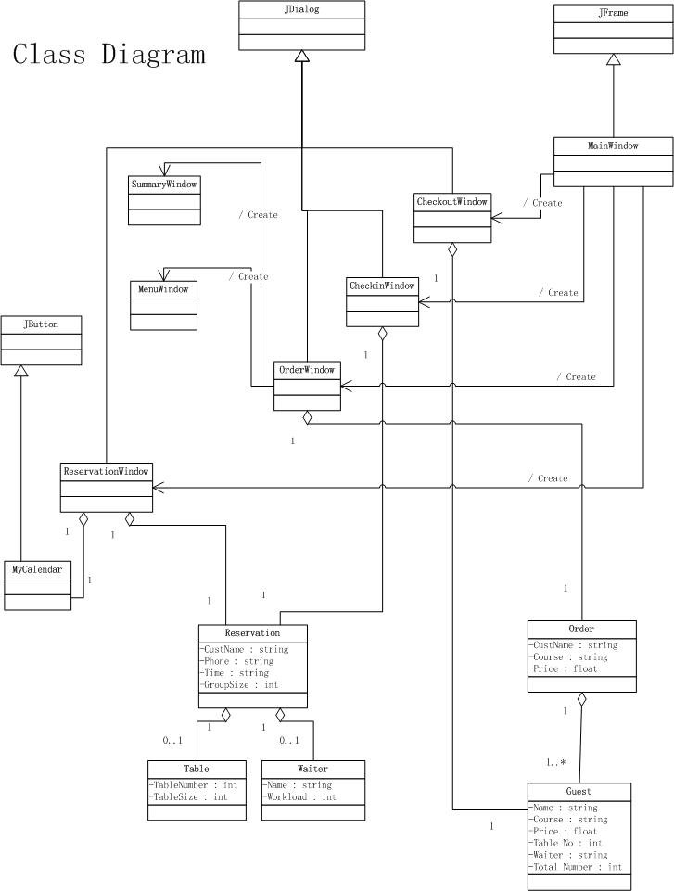

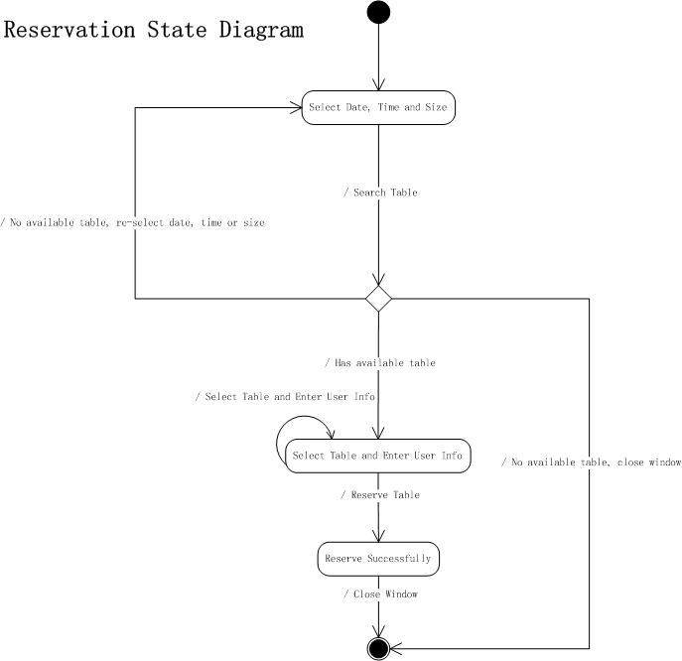

Author: Yi Yang

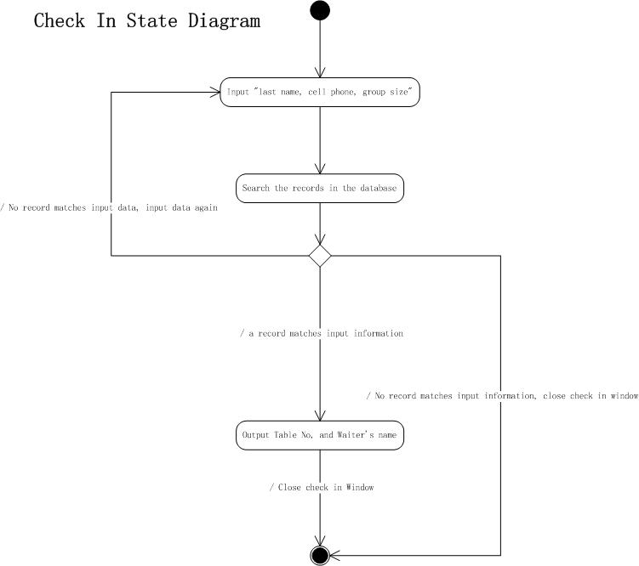

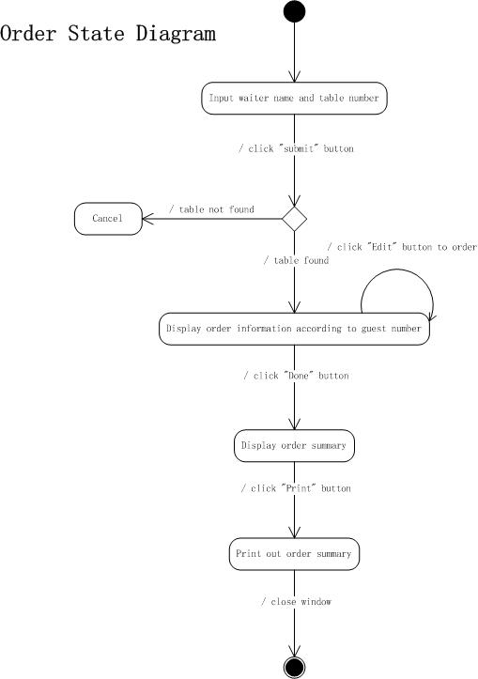

Author: Kun Chen

Author: Rui Da

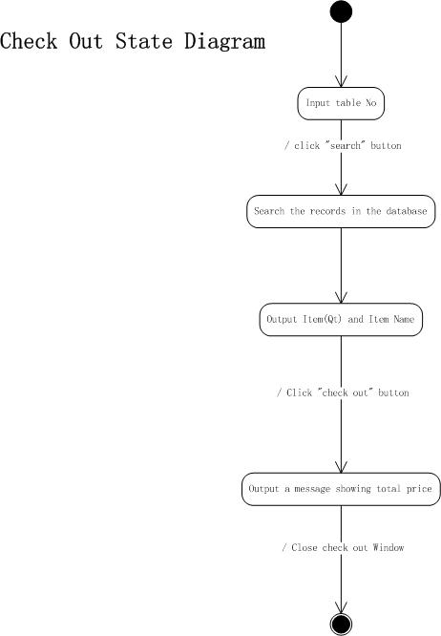

Author: Kun Chen

Reservation Scenario (Yi Yang)

1. One customer calls the restaurant to make a reservation on Nov 11, 2 persons for dinner, the receptionist opens the reservation window, select date, time and size, then search for available tables.

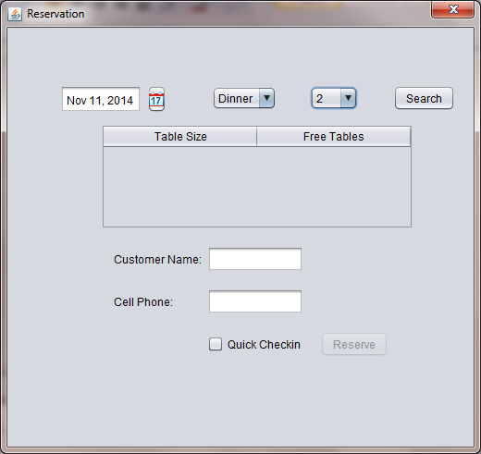

1. System displays all the available tables

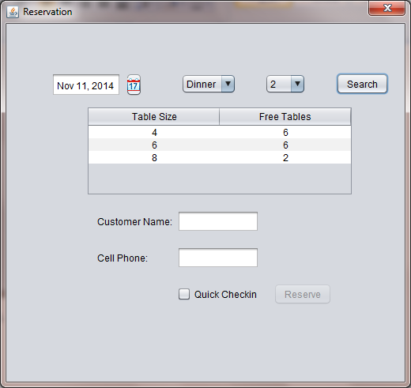

1. The receptionist selects one table, and enters user’s name and phone, clicks reserve button.

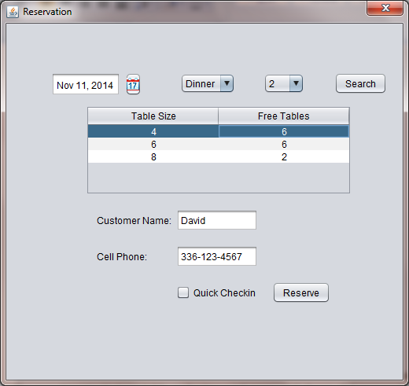

1. System pops out confirmation window to display reserving successfully.

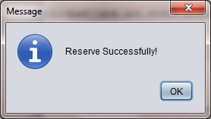

1. Click ok button, and close reservation window to return to main window.

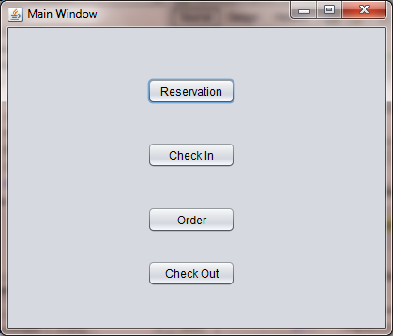

Check-In Scenario (Kun Chen)

**1st scenario with screen shots for use case of “check in”:**

1. Chase, a front desk receptionist, meets with a customer who has already made reservation before coming to the restaurant. When he knows that the customer wants to check in, he clicks the “check in ” button in the main interface. 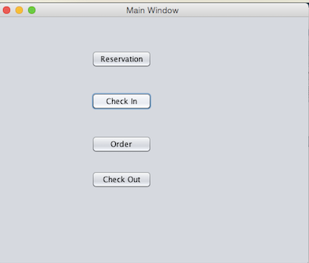

2. System displays a new interface to prompt receptionist to type last name of customer, cell phone number and group size.

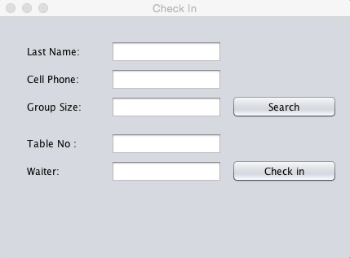

3. Waiter Chase types the information provided by costumer. He types “Chen” into “user name” text box, types “123-345-3232” into “cell phone” text box and types “4” into “group size” text box.

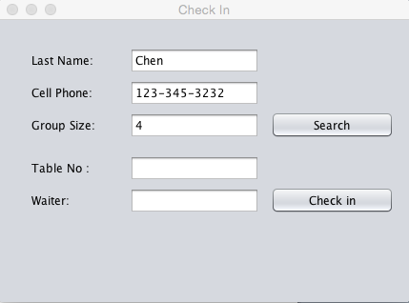

4. After Chase types the information provided by customer, he clicks “Search” button. And System will find out a record, which matches what he types in. As a result, interface will display “Table No:” 3 and “Waiter” David that are assigned to this customer.

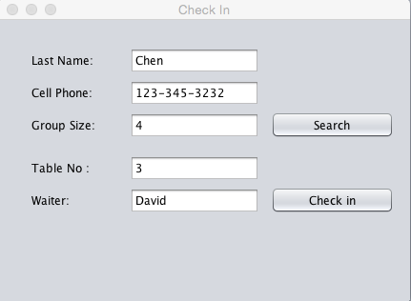

5. Waiter Chase clicks the “check in” button to complete it. The system will pop out a window showing “check in successfully” to confirm the process of check in is successful.

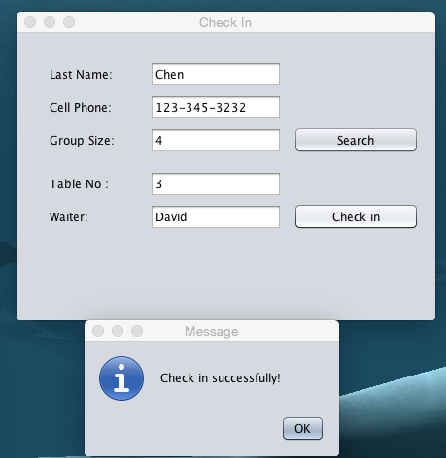

**2nd scenario with screen shots for use case of “check in”:**

1. Chase, a front desk receptionist, meets with a customer who has already made reservation before coming to the restaurant. When he knows that the customer wants to check in, he clicks the “check in ” button in the main interface. 

2. System displays a new interface to prompt receptionist to type last name of customer, cell phone number and group size.



3. Waiter Chase types the information provided by costumer. He types “Chen” into “user name” text box, types “123-345-3231” into “cell phone” text box by mistake and types “4” into “group size” text box.

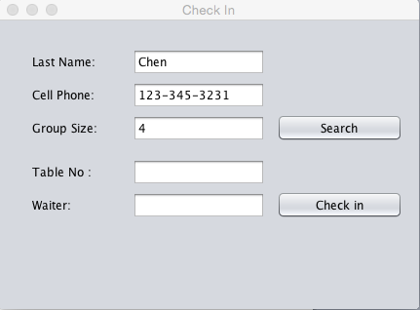

4. After Chase types the information provided by customer, he clicks “Search” button. And System will not find out a record, which can match what he types in. As a result, interface pop out a message box showing that “Invalid Information for Reservation ”.

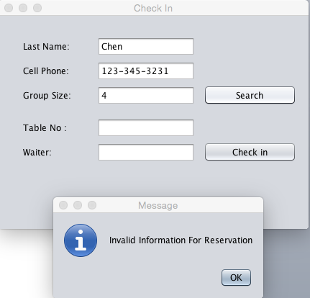

Order Scenario (Rui Da)

1. Waiter Alex takes guests to their table. He clicks on “Order” button and types in his name and table number, which is 1. Click “Submit”, 2 rows of guest information should display.

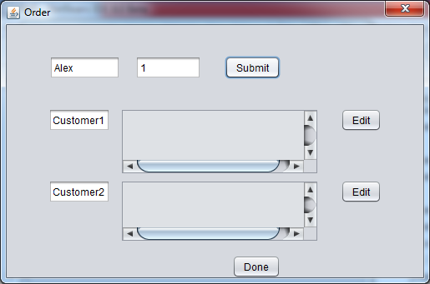

2. Click on “Edit” button for guest 1 to make order. Choose 1 chicken wings and 1 beef ramen.

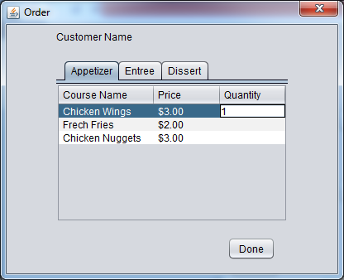

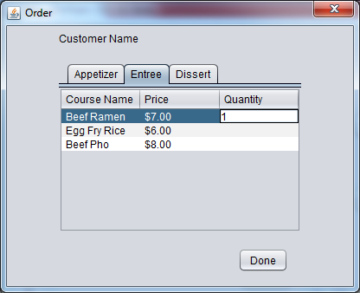

3. Click on “Done”. Order information for guest 1 should display.

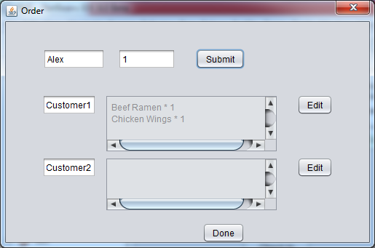

4. Click on “Edit” button for guest 2 to make order. Choose 1 coconut ice cream and 1 beef ramen. Click on “Done”. Order information for guest 2 should display.

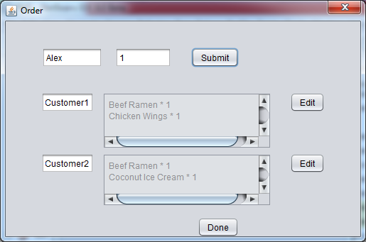

5. Click “Done” button, order summary for both guests should display.

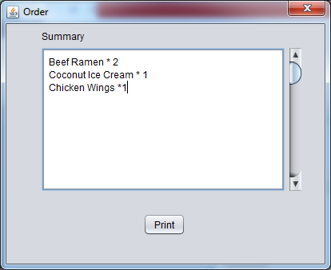

6. Click “Print”, return to main window.

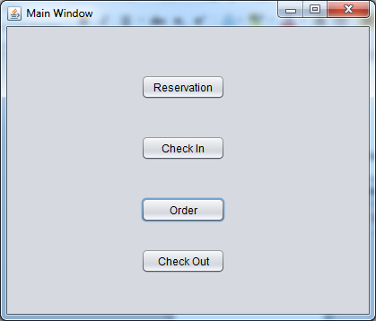

Check-Out Scenario (Kun Chen)

1. When a costumer finishes dinner and wants to check out, the receptionist Chase choose “check out” in the main interface.

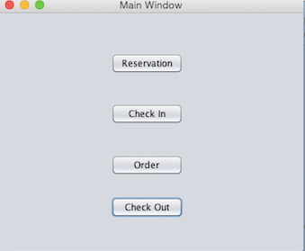

2. System displays a new interface to prompt receptionist to type table number.

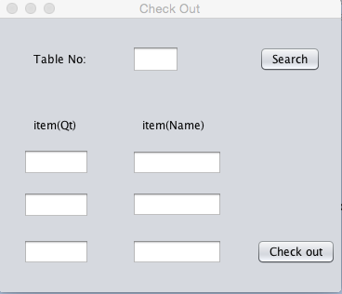

3. The receptionist will type this customer’s table Number that is 4 and click “Search” button.

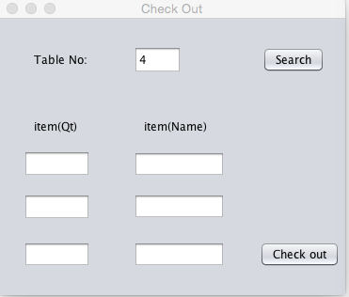

4. The system will display the order information of this customer like the item name as well as the item quantity corresponding to it.

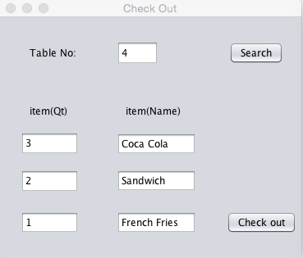

5. Then the receptionist clicks the “Check out” button and a message box will pop out showing the total price of the order.

